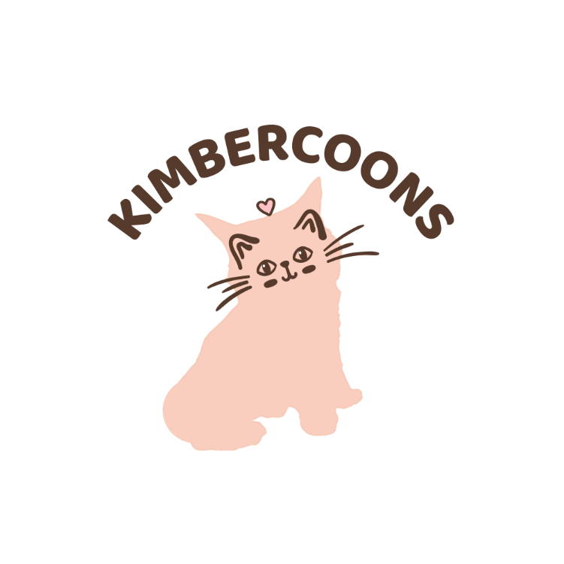
KimberCoons
Kitten Application

Thank you for your
Interest in a KimberCoons kitten!
We are excited for you to become a
Member of the KimberCoons family!

Being adopted by a Maine Coon is a big deal! That’s why we ask that all purrspective pet parents fill out an application so that we can get to know you better, and be able to match you with the best kitten. There is a lot of information that we ask for, but we want to be sure that a Maine Coon will be a good fit for your family.

Date of Application __________________
Is this application for a kitten currently available on our website? ____ Is this for one of our available rescues? ________
If not, is there a particular pairing that you are most interested in? If so, please indicate which pair you fell in love with? ______________________________
What color of Maine Coon are you most interested in?
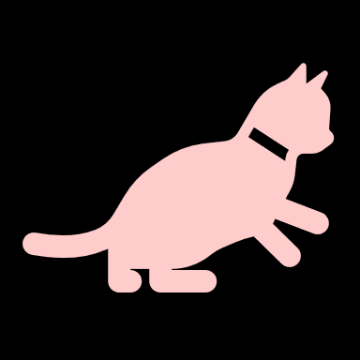
Blue White
Black Tabby
Blue or Black Smoke Shaded
Ginger Calico
Silver I don’t care, I just want Fluffy
Are you interested in a male or a female? __________

Are there any particular traits that you are wanting?

Polydactyly (extra toes)
Heterochromacy (bi-color eyes)

Names: _________________________________________________________
Address: ________________________________________________________
________________________________________________________
Phone Number(s): _______________________________________________
Email address: _______________________________________________
Do you have any other pets in your household? If so, please brag about them! ___________________________________________________________________________________________________________________________________________________________________________
Are you aware that Maine Coons are one of the larges domestic cat breeds that are legal in the United States? (In other words, Kitty may be bigger than puppy)
No or Yes, that’s why I want one, silly
Have you ever given away of sold any pets in the past? _______
Do you agree that if in the future, at any time, no matter how long it has been, you decide that you no longer want your KimberCoons Maine Coon or find that you are no longer able to take care of them, you will sell your KimberCoons Maine Coon back to KimberCoons? ____________ KimberCoons will pay $500 for the surrendered cat and ownership will be transferred back to KimberCoons.
What is your profession? _________________________________
Do you currently have a veterinarian? _________ If so, who are they? (Name and location) ________________________________

KimberCoons reserves the right to decline an application if we feel that for some reason one of our Maine Coons may not be the best fit for your family. Filling out an application is not a guarantee of a kitten or future kitten. (initial) ___________

Thank you for your interest in KimberCoons! We look forward to you becoming a part of our Fluffer Family!!
If you are matched to a kitten or a litter, you will be contacted so that you can choose your kitten and place a deposit on the little ball of fluff. For more information about our pricing, payment options, and deposit process, please see the pricing section listed on the website.
www.kimbercoonsmc.com

